Joshua Arrants and Leon Maxwell

WEB330 – Group Project

Overview:

• Three students per group

• Single Page Application using Knockout.js

Application type:

• JavaScript Trivia

Number of questions:

• 10

Functionality:

• Testers should have the ability to move forward and backwards in the quiz

Provide a summary of the results and include the following:

• Rank (see rank criteria)

• Score (percentage based)

• Questions

• Answers

• Correct answers

Ranking criteria:

• Expert: 8-10 correct answers

• Novice: 6-8 correct answers

• Beginner: Less than 6 correct answers

Requirements:

• Custom HTML (must be written exclusively by your group – no open-source templates)

• Custom CSS (you may either write the code yourself or use Boostrap/W3.css – no other frameworks will be allowed)

• ViewModel's (must be written exclusively by your group – no open-source templates)

• GitHub repository for hosting, tracking, and managing the development process.

• For the questions, choose your own, but they must be from the topics covered in WEB 230/231 (hopefully you took notes)

**Questions:**

1. What pattern in JavaScript restricts instantiation of a class to a single object?
2. Constructor Pattern
3. Singleton Pattern
4. Prototype Pattern
5. Mixin Pattern
6. Which looping statement is known as JavaScript’s basic loop?
7. for loop
8. do/while loop
9. while loop
10. for/in loop
11. The _______ method returns a string that follows the syntax of the function declaration statement.
12. toString()
13. bind()
14. call()
15. apply()
16. The _______ pattern aims to encapsulate method invocation, request, or operations into a single object and gives us the ability to both parameterize and pass method calls around that can be executed at our discretion.
17. Prototype
18. Factory
19. Command
20. Façade
21. JavaScript’s reserve word ______ causes the innermost enclosing loop or switch statement to exit immediately.
22. Try
23. Catch
24. Else
25. Break
26. Which of the following is NOT a correct way of declaring an array in JavaScript?
27. var arr = [1, "two", 3 , 4 ];
28. var arr = new Array();
29. var[] arr = new Number()[5]; ****
30. None of the above
31. Which of the following is true about variable naming conventions in JavaScript?
32. You should not use any of the JavaScript reserved keyword as variable name.
33. JavaScript variable names should not start with a numeral 0 − 9.
34. Both of the above. ***
35. None of the above.
36. Which of the following is a valid JavaScript function?
    1. var myFunc = function myFunc{ };
    2. function myFunc(){ };****

c. myFunc function(){ };

d. function myFunc = { };

1. Which of the following is true about variable naming conventions in JavaScript?
   1. You should not use any of the JavaScript reserved keyword as variable name.
   2. JavaScript variable names should not start with a numeral 0 − 9.
   3. Both of the above. ***
   4. None of the above.
2. Which built-in method combines the text of two strings and returns a new string?
   1. append
   2. concat ***
   3. attach
   4. None of the above.

**Sketches/Wireframe Examples:**

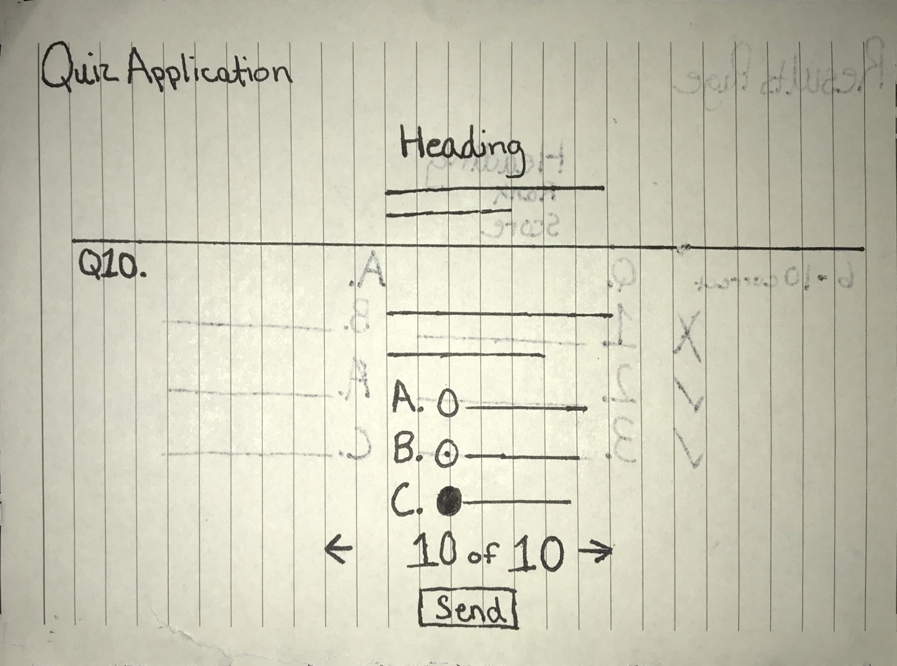

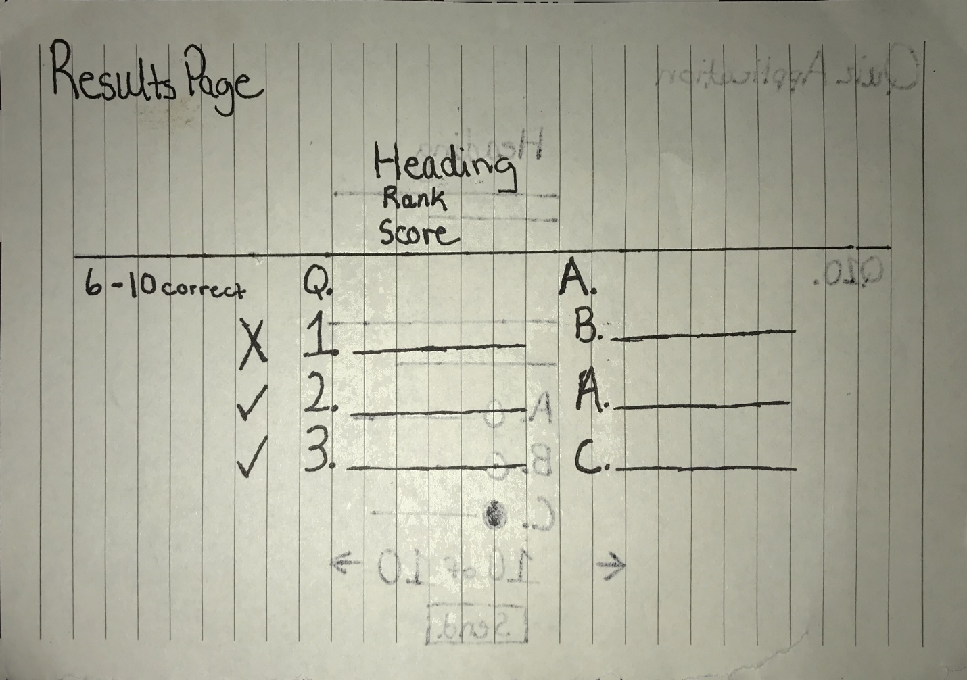

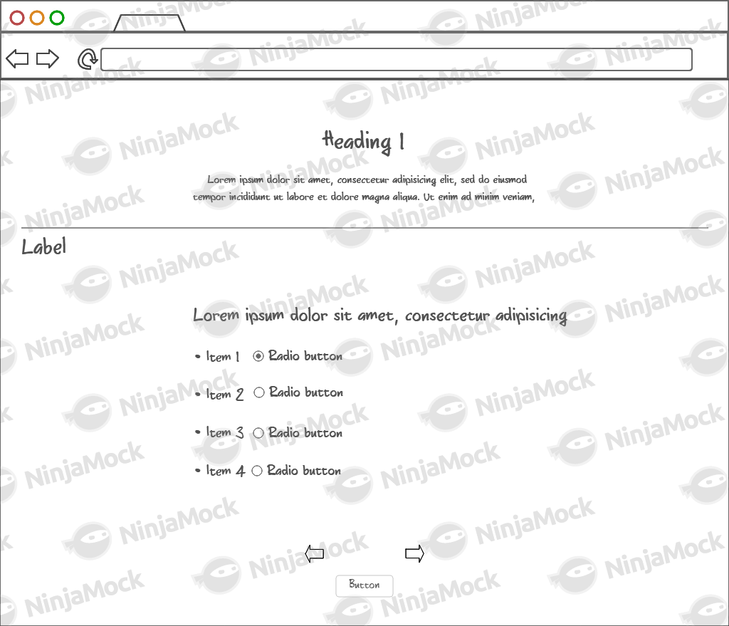Quiz Application

Results Page

